Hawaii gifted assoc. Attain & Sustain gallery Prospectus 2022 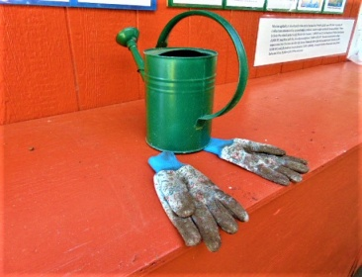
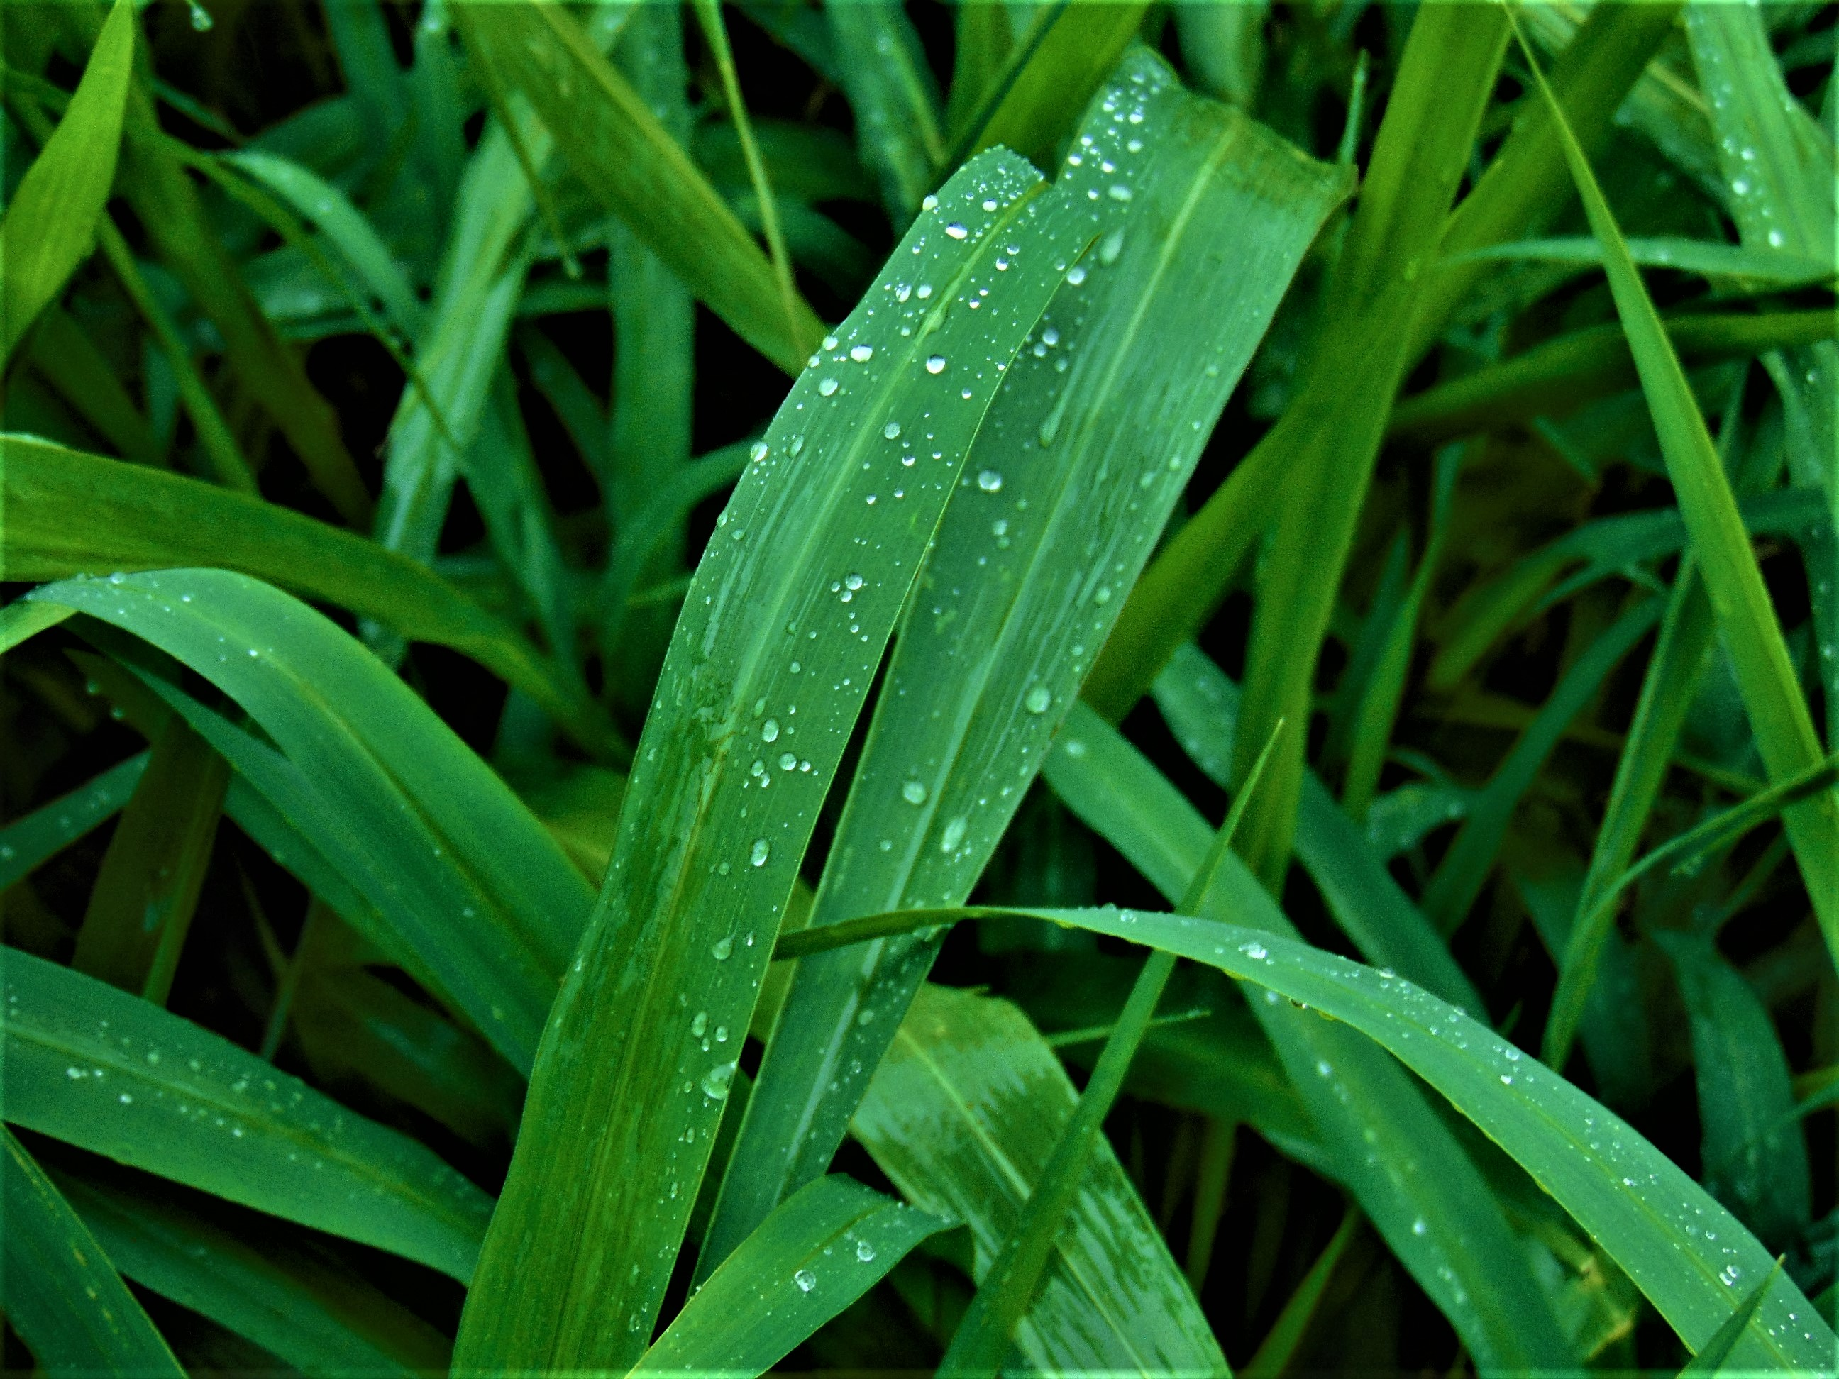
Submissions now being Accepted Deadline June 15th, 2022
Name
Address phone
Email
Title | Medium | Size | Price
YOU MUST SIGN WAIVER OF LIABILITY TO PARTICIPATEI N THE ONLINE GALLERY
I agree to give Hga permission to use my name and image(s) in Hga publications, website and any Hga publicity for PR
In the event of a sale, 20% will go to Hga for the Scholarship Fund. Hga will contact me upon request for purchase of my image(s) I am the owner of listed images.
Signature: ________________________________________Date_________________
Guidelines;
2 images, songs, videos per Entry
Jpg form at 150 dpi
Labeling example; cchang_1.jpg./ Price
Entry Donation Fee $10.00 per student (Minors need Parent or Guardian sig)/$20 all others
Payment: Check or Guaranteed Funds to Hga (Hawaii gifted assoc.)
VISA/MC Accepted card# exp
Name on Card
Mail to : Hawaii gifted assoc. P.O.Box 22475 Honolulu,Hi 96822-2475
Online Show begins 9/2022 to 9/2023
Visit; http;//higifted.info for previous online gallery examples
Donations to Hawaii gifted assoc & Hga Scholarship Fund
*Hga will not be responsible for infringement of original work submitted. Final product is copyright with Hga
DeadlineJuly1st, 2022
Emailhigifted@aol.com

