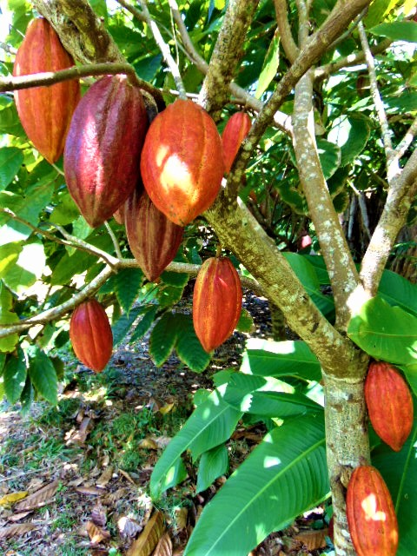
Cacao-o-doodle do!!

November 13th, Sunday,11-1pm
Come early , shop, mingle and visit the Waiahole Nursery and Gardens. Community Service Project and %benefit hga Scholarship Service Award!
FEIN 99-0169246/ http://.www.higifted.info/ higifted@aol.com

