Volunteer at Waiahole Gardens and Nursery
Help us Attain and Sustain an Active Healthy Life!

Who: Volunteer 52+
What: Gardening, planting, harvesting, caring for crop and flora
Where: Waiahole Gardens and Nursery
When: April 2023
How: once a month or once every week you choose!
*Transportation to be arranged
* First visit includes a take home /care for plant just for you! Keep a journal and let us know how you both are doing!

ATTAIN AND SUSTAIN
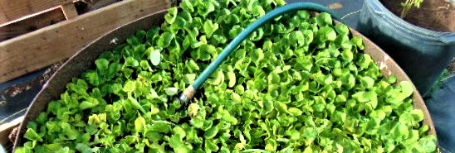
ATTAINING one’s goals and accomplishing an achievable task while SUSTAINING a level of excellence

**Collaboration with Chaminade University of Honolulu Dept. of Education Organizational Leadership / Hawaii gifted assoc. / Waiahole Nursery and Garden / Pohai Nani/ WW Olelo/ Serteens and Windward Waiahole Community.**

