Shop Hawaii gifted assoc. your donation purchase benefits the hga Scholarship Fund
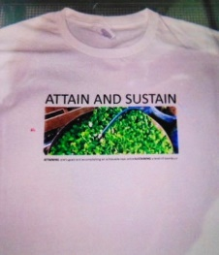
Attain and Sustain Hga T-Shirt $25
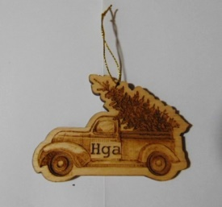
2024 Hga Holiday Ornament $5
Ountry Kitchen Dips $7.00 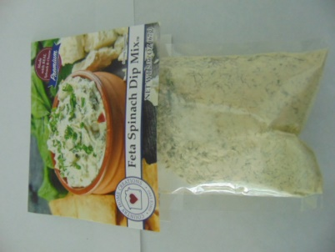  Spinach, Garden Medley, Cucumber Onion
• ADD your fresh veggies or fruits to it! 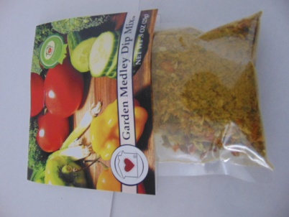
Potato, Pumpkin Dip for the Holidays! 
• Add Front Porch Lemonade $ 5.00 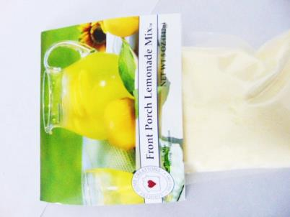
Mini Farm House Rnach Mix or Mini garlic and Herb mix for the Summer! $ 3.50 / 2 for $6
Seed monies for Hga Scholarships , Donate to a Bird Feeder and use it all year round!
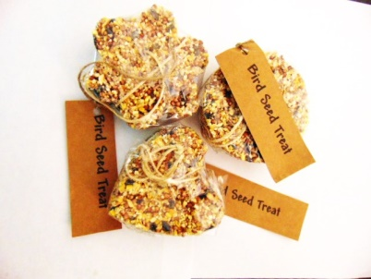
$6.00 ea or 2/$10
Sustaining Recycled products
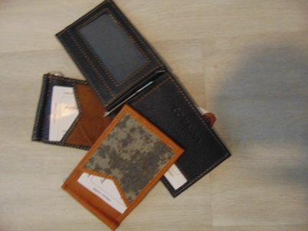 Clip Wallet /Leather remnants $ 10
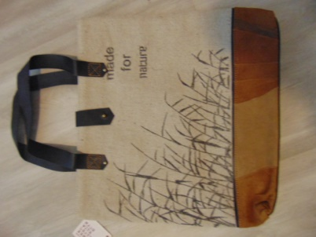
Jute Fibers with leather remnants $35.00
ORDER FORM
Date:
Purchasec by Name:
Address
City/State/Zip:
Ship to or same :
Donation Payment: Name
Ck. Money order or CC #________________exp___
Mail to: Hawaii Gifted Assoc. /P.O. Box 22475/Hon.HI 96822
**For Hawaii gifted assoc. use only**
Payment Rec’d date:
Ship Date: Invoice #

