Shop Hawaii gifted assoc. your donation purchase benefits the hga Scholarship Fund
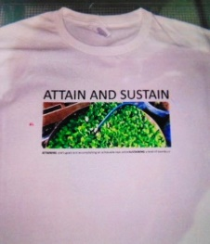
Attain and Sustain Hga T-Shirt $25
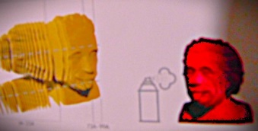
Einstein Puzzle $ 35
Ountry Kitchen Dips $7.00 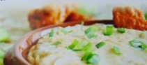 Spinach, Garden Medley, Cucumber Onion
• ADD your fresh veggies or fruits to
Seed monies for Hga Scholarships , Donate to a Bird Feeder and use it all year round!
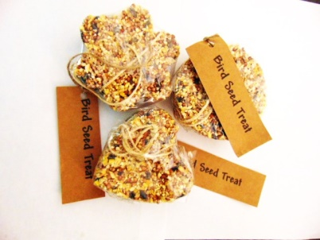
$6.00 or 2/$10

ORDER FORM
Date:
Purchase by Name:
Address
City/State/Zip:
Ship to or same :
Donation Payment: Name
Ck. Money order or CC #________________exp___
Mail to: Hawaii Gifted Assoc. /P.O. Box 22475/Hon.HI 96822
**For Hawaii gifted assoc. use only**
Payment Rec’d date:
Ship Date: Invoice #

